Module 1 - Introduction of Graphics System:

APPLICATIONS.

Presentation Graphics

Computer Art

Visualization

Image Processing

Graphical User Interface

Cathode-Ray Tubes (CRT)

- still the most common video display device presently.

An electron gun emits a beam of electrons and hits on the phosphor-coated screen.

The number of points displayed on a CRT is referred to as resolutions (eg. 1024x768).

There are 2 kinds of redrawing mechanisms:

Raster-Scan and Random-Scan.

Rasterization is the process of converting vector graphics into raster graphics.

More formally, it converts the shapes into a set of pixels and displays it on the monitor screen or printer.

a. Raster Scan.

The electron beam is swept across the screen one row at a time from top to bottom.

Each complete scanning of a screen is normally called a **frame**.

The refreshing rate is called the **frame rate.**

Picture definition is stored in a memory area called the **frame buffer.**

This frame buffer stores the intensity values for all the screen points.

Each screen point is called a **pixel**

b. Random-Scan (Vector Display).

The CRT's electron beam is directed only to the parts of the screen where a picture is to be drawn.

---------------------------------------------------

Module 2 - Output Primitives

For Line Drawing in Raster Devices

1. DDA (Digital Differential Analyzer) Algorithm.

incremental method of scan conversion of lines.

the calculation is performed using the results of prev steps.

Adv-

1. Faster than directly using the line equation.

2. avoids the generation of the same points.

3. easy method because each step just involves two additions.

Disadv-

1. round off errors in floating points.

2. rounding off consumes a lot of time.

2. Bresenham's Line Algorithm.

used for scan converting a line.

efficient method.

because it involves only integer addition, subtractions, and multiplication operations

performed very rapidly by the computer, hence lines can be generated quickly.

Adv-

1. faster than DDA since it has no floating-point calculations.

2. avoids the generation of the same points.

Disadvantages-

1. non-smooth lines.

2. Initializing is not a part of Bresenham’s.

3. slope of the line is positive and less than 1.

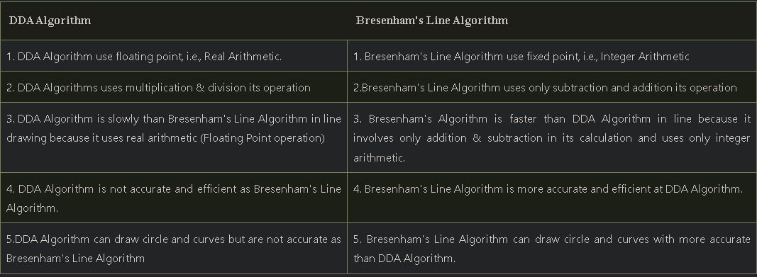

Midpoint Algorithm for

3. Circle.

based on the function  
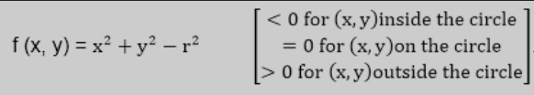

Assumptions -

the center is the origin, the radius is an integer, 8-way symmetry.

4. Ellipse

The ellipse is also a symmetric figure like a circle but is four-way symmetry rather than eight-way.

based on the F(x,y) ellipse function

*Aliasing is a distortion of information due to under-sampling(results in loss of info in the picture) / staircase type or jagged visual.

Solved by Antialiasing techniques -

Using High-Resolution displays.

Pre-filtering

post-filtering,

Supersampling,

pixel phasing.

Filled Area Primitive:

1. Scan line Polygon Fill algorithm

the algorithm locates the intersection points of the scan line with the polygon edges. These intersection points are shorted from left to right. Then, we fill the pixels between each intersection pair.

2. inside-outside tests

for nonstandard polygons (whose edges intersect)

3. Boundary Fill

uses the recursive method

This algorithm starts at a point inside a region and paints the interior outward towards the boundary (of the same color)

{

1. Four connected approaches: In this approach, left, right, above, below pixels are tested.

2. Eight connected approaches: In this approach, left, right, above, below and four diagonals are selected.

}

Disadv-

1. may not fill regions sometimes correctly when some interior pixel is already filled with color

4. Flood fill algorithm.

Same as Boundary fill but with different colors of the boundary.

Disadv-   
1. Very slow

2. Might fail for very large polygons.

{

we start from a specified interior point (x, y) and reassign all pixel values are currently set to a given interior color with the desired color. Using either a 4-connected or 8-connected approach, we then step through pixel positions until all interior points have been repainted.

}

---------------------------------------------------